Cavendish Church of England Primary School Review of 2023 – 2024 and plan for 2024 - 2025
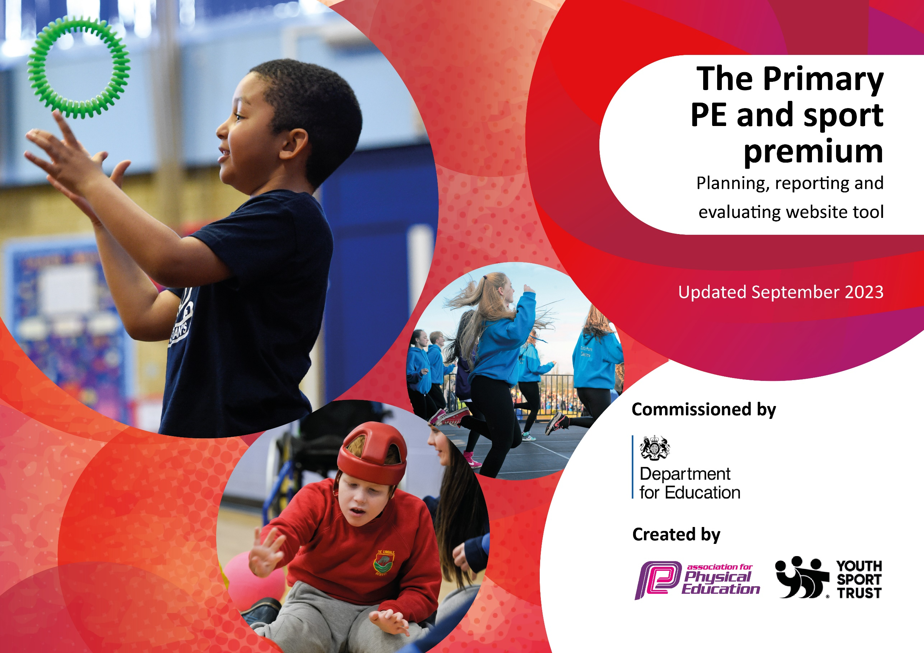

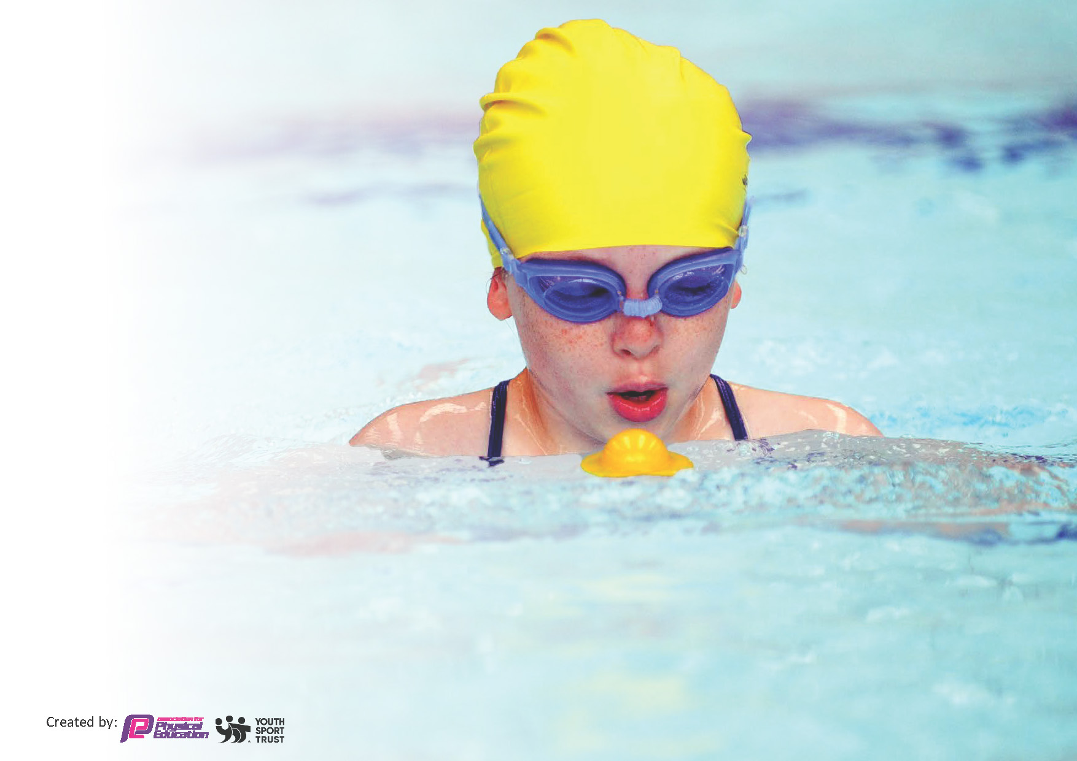
This template can be used for multiple purposes:
by:
- It enables schools to effectively plan their use of the Primary PE and sport premium
- It helps schools to meet the requirements (as set out in guidance) to publish information on their Primary PE and sport premium
- It will be an effective document to support Ofsted inspections enabling schools to evidence progress in Physical Education (PE) and evidence swimming attainment, which forms part of the PE National Curriculum. We would recommend schools consider
the Intent, Implementation and Impact of any spend, as examined within the Education Inspection Framework.

It is important that your grant is used effectively and based on school need.

Schools must use the funding to make additional and sustainable
improvements to the quality of the PE, School Sport and Physical Activity (PESSPA)
they offer. This means that you should use the Primary PE and sport premium to:

- Build capacity and capability within the school to ensure that improvements made now will benefit pupils joining the school in future years
- Develop or add to the PESSPA activities that your school already offers.

The Primary PE and sport premium should not be used to fund capital spend projects; the school’s core budget should fund these. Further detail on capital expenditure can be found in the updated Primary PE and sport premium guidance.

The Primary PE and sport premium guidance, outlines 5 key priorities that funding should be used towards. It is not

necessary that spending has to meet all the key priorities, you should select the priorities that you aim to use any funding towards.

Although completing this template is not a requirement for schools, schools are required to publish details of how they spend this funding. Schools must also outline what the impact this funding has had on pupils’ PE and sport participation and attainment and how any spending will be sustainable in the future. All funding must be spent by 31st July 2024.

The Department for Education has worked closely with the Association for Physical Education (afPE) and the Youth Sport Trust (YST) to develop this template and encourages schools to use it. This template is an effective way of meeting the reporting requirements of the Primary PE and sport premium.
Review of last year’s spend and key achievements (2023 / 2024)

We recommend you start by reflecting on the impact of current provision and reviewing your previous spend.

Activity/Action | Impact | Comments
Extend lunchtime and afterschool sport sessions/activities for pupils.  Further extend quality of PE provision through new scheme of work & staff CPD  Bikeability course run for year six pupils.  Playground markings were placed during the second half of the summer term.  Sports markings for Sport’s Day on the Cavendish Green.  Premier Sports activity day for year five and six pupils.  Additional swimming sessions to ensure all the year five / six cohort reached the expected standard | Pupils have enjoyed the opportunity of the additional sessions at lunchtime and after school and this has improved behaviour at lunchtime as well as improving the level of physical activity.  New PE scheme has been introduced and has improved staff knowledge and outcomes for children.  Children have an increased understanding of how to ride their bicycles safely and have some knowledge to keep themselves safe on the road.  Children have used the trail that was laid out and physical activity at lunchtimes and playtimes have increased.  Sports day was held with parents and the village community invited. The use of the markings allowed the activities to take place.  Year Six pupils enjoyed a day of physical activity ran by Premier Sports which involved sports and team building activities.  See below for the number of children who are now able to swim at the appropriate standard. | To be continued in the next academic year and extended with the use of further lunchtime and after school clubs both with Prestige and also Premier Sports.  The scheme is being maintained into the next academic year to allow the impact to be continued.  Bikeability has been booked for the next academic year to continue the children’s education and to increase physical activity.  To continue to monitor the use of this area and to see if there are further opportunities to develop further markings.  The markings continued to be used by children in the village increasing their levels of physical activity.  Though it was disappointing that children in the Neptune class did not get to have a residential experience in the provision of the activities day meant that some aspects of these activities were undertaken.  The use of Premier to deliver activity days and other such sessions was noted as effective and opportunities for further days in the following academic year will be explored.  There are considerable costs with swimming because of the location of the school with few local pools. Consider the provision of a temporary pool at the school in the next academic year.

Key priorities and Planning
This planning template will allow schools to accurately plan their spending.

Action – what are you planning to do | Who does this action impact? | Key indicator to meet | Impacts and how sustainability will be achieved? | Cost linked to the action
Continue to provide lunchtime clubs and extend with the use of Premier Sports.  Continue to provide after school clubs and extend to three afternoons per week.  Provide Forest Schools for each class for a sustained number of sessions. Mrs Lewis is a fully trained Forest School Practitioner whose skills will be utilized. | Both Prestige and Premier Sports have agreed to provide clubs three lunchtimes during the course of the week.  Prestige Sports have been invited to continue their after clubs and Premier Sports have been asked to provide a football and gymnastics after school clubs.  Forest Schools will give the children opportunity to explore and play outside and to gain skills and knowledge. Research demonstrates that the provision of Forest Schools gives improved educational outcomes | Key indicator 2 -The engagement of all pupils in regular physical activity – the Chief Medical Officer guidelines recommend that all children and young people aged 5 to 18 engage in at least 60 minutes of physical activity per day, of which 30 minutes should be in school.  Key indicator 4: Broader experience of a range of sports and activities offered to all pupils.  Key indicator 2 -The engagement of all pupils in regular physical activity – the Chief Medical Officer guidelines recommend that all children and young people aged 5 to 18 engage in at least 60 minutes of physical activity per day, of which 30 minutes should be in school.  Key indicator 4: Broader experience of a range of sports and activities offered to all pupils.  Key indicator 2 -The engagement of all pupils in regular physical activity – the Chief Medical Officer guidelines recommend that all children and young people aged 5 to 18 engage in at least 60 minutes of physical activity per day, of which 30 minutes should be in school. | More pupils meeting their daily physical activity goal, more pupils encouraged to take part in PE and Sport Activities.  More pupils meeting their daily physical activity goal, more pupils encouraged to take part in PE and Sport Activities.  Mrs Lewis has left the teaching staff of the school but will be reemployed specifically for Forest Schools after the required monthly break. | £3,000 costs for additional coaches to support lunchtime sessions.  £3,000 costs for additional coaches to support lunchtime sessions.  £13,000

CPD for teachers with the continued use of the PE scheme to enhance staff knowledge | Primary generalist teachers. | Key Indicator 1: Increased confidence, knowledge, and skills of all staff in teaching PE and sport.  Key indicator 5: Increased participation in competitive sport. | Primary teachers more confident to deliver effective PE supporting pupils to undertake extra activities inside and outside of school. | £500 for 4 teachers to undertake CPD.

Key achievements 2023-2024
This template will be completed at the end of the academic year and will showcase the key achievements schools have made with their Primary PE and sport premium spending.

Activity/Action | Impact | Comments
See above review section.

Swimming Data
Meeting National Curriculum requirements for swimming and water safety.
Priority should always be given to ensuring that pupils can perform safe self-rescue even if they do not fully meet the first two requirements of the National Curriculum programme of study

Question | Stats: | Further context  Relative to local challenges
What percentage of your current Year 6 cohort can swim competently, confidently and proficiently over a distance of at least 25 metres? | % | Use this text box to give further context behind the percentage.  e.g., 30% - we are struggling to get pool space due to our local pool closing so we have had to use a much smaller local school pool. We have had to limit the number of pupils attending swimming lessons during one term which means some pupils have attended fewer swimming lessons than others.
What percentage of your current Year 6 cohort can use a range of strokes effectively [for example, front crawl, backstroke, and breaststroke]? | % | Use this text box to give further context behind the percentage.  e.g., Even though your pupils may swim in another year please report on their attainment on leaving primary school at the end of the summer term 2024

What percentage of your current Year 6 cohort are able to perform safe self-rescue in different water-based situations? | % | Use this text box to give further context behind the percentage.
If your schools swimming data is below national expectation, you can choose to use the Primary PE and sport premium to provide additional top-up sessions for those pupils that did not meet National Curriculum  requirements after the completion of core lessons. Have you done this? | Yes/No
Have you provided CPD to improve the knowledge and confidence of staff to be able to teach swimming and water safety? | Yes/No

Signed off by:

Interim Executive Headteacher: | Sean Cornish
Subject Leader or the individual responsible for the Primary PE and sport premium: | Lizzy Clarke – PE lead
Governor:
Date: | August 2024

Please note due to changes in leadership throughout the academic year it has not been possible to update this section of the document.

